CAP Theorem for distributed systems :
We must understand the CAP theorem when we talk about NoSQL databases (or) when we are going to design any distributed system.

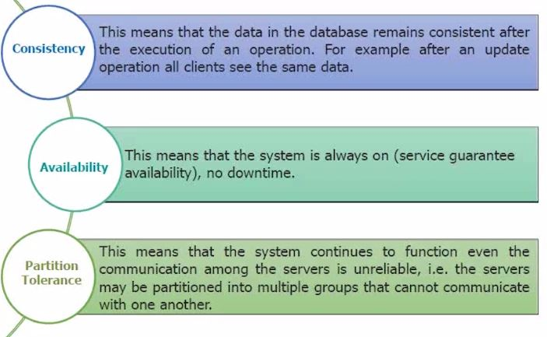
Partition Tolerance :
It says how good your system is when you're actually partitioning the data i.e. System continues to work despite message loss or partial failure.
A system that is partition-tolerant can sustain any amount of network failure that doesn’t result in a failure of the entire network. Data records are sufficiently replicated across combinations of nodes and networks to keep the system up through intermittent outages.

Storage systems that fall under Partition Tolerance with Consistency (CP): MongoDB, Redis, AppFabric Caching, and MemcacheDB. CP systems make for excellent distributed caches since every client gets the same data, and the system is partitioned across network boundaries.

Theoretically, it is impossible to achieve all 3 requirements. CAP provides the basic requirements for a distributed system to follow '2 of the 3 requirements'.

Just FYI, MongoDB falls under "Consistency and Partition tolerance". It means that we are compromising with "Availability" in MongoDB. Let's discuss about this point when we talk about MongoDB Replication.

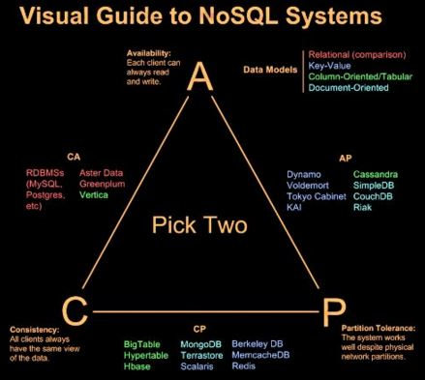

BASE :
Luckily for the world of distributed computing systems, their engineers are clever. How do the vast data systems of the world such as Google’s BigTable and Amazon’s Dynamo and Facebook’s Cassandra (to name only three of many) deal with a loss of consistency and still maintain system reliability? The answer is BASE (Basically Available, Soft state, Eventual consistency). BASE system gives up on consistency of a distributed system.
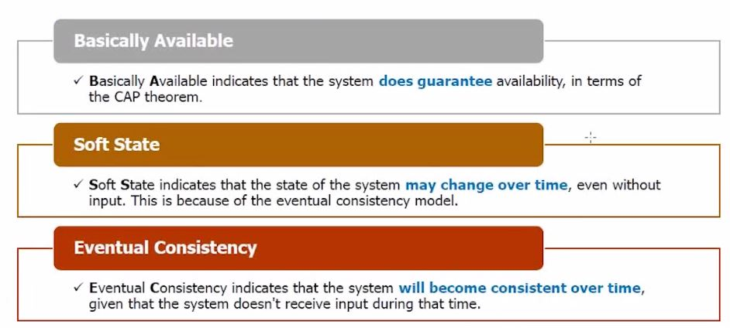

Basically Available :
This constraint states that the system does guarantee the availability of the data as regards CAP Theorem; there will be a response to any request. But, that response could still be ‘failure’ to obtain the requested data or the data may be in an inconsistent or changing state, much like waiting for a check to clear in your bank account.

Soft State :
The state of the system could change over time, so even during times without input there may be changes going on due to ‘eventual consistency,’ thus the state of the system is always ‘soft.’

Eventual Consistency :
The system will eventually become consistent once it stops receiving input. The data will propagate to everywhere it should sooner or later, but the system will continue to receive input and is not checking the consistency of every transaction before it moves onto the next one.

